Change Request
for the update of a normative CGI-MP Deliverable
Note: the purpose of this document is to give guidelines to parties who want to introduce a request to change an existing normative CGI-MP deliverable. Such change requests are subject to the approval of the CGI-MP Working Group in charge of the related deliverable and subsequent the CGI-MP Plenary. Please consult the CGI-MP Deliverables Approval and Maintenance Process for additional details. Change requests are to be sent to CGI-MP Support CGI.Support@swift.com. All change requests conforming to this template received by March 1st will be considered for development in the following yearly CGI-MP maintenance cycle which completes with publication of new deliverables on July 1st the same year.
- Origin of the request:
A.1 Submitter: Name of the submitter, organization, group, initiative or community that submits the change request.
CGI-MP Workgroup 1 (pain.001 & pain.002), date of CR request: January 2017
A.2 Contact person: person(s) who can be contacted to get additional information on the request (name, e-mail, telephone)
Kerstin Schönwitz (Kerstin.Schoenwitz@db.com)
- Related CGI-MP deliverables:
This is a list of CGI-MP normative deliverables which is impacted by the change request.
Credit Transfer Base Template MIG
Credit Transfer Appendix B – Country Specific Data Requirements (to be updated for synchronization with new Credit Transfer Base Template MIT)
Description of the change request:
The change request form must be exhaustive for all particular change requested to each normative CGI-MP deliverable (for example, adding, deleting, modifying, renaming, changing the cardinality, moving an element/component, or changing the type of an element, changing a code list. adding new functionality which requires several changes).
Change requests may not lead to creation of new messages. In such cases, a new work item proposal needs to be submitted to the CGI-MP Plenary.
The review of US NACHA payment country-specifics has revealed the requirement for usage of a number of tags, which are currently defined as NU (Not Used) in both above mentioned documents (deliverables).

Debtor agent section / column ACH Domestic & Intl.:
Tag 6.1.7 Name – change status from NU to C
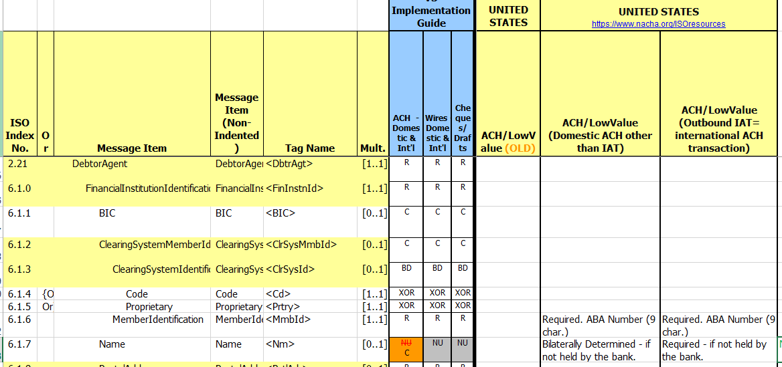

IntermediaryAgent1 section / column ACH Domestic & Intl.:
Tag 2.71 Intermediary Agent1 – change from BD to C
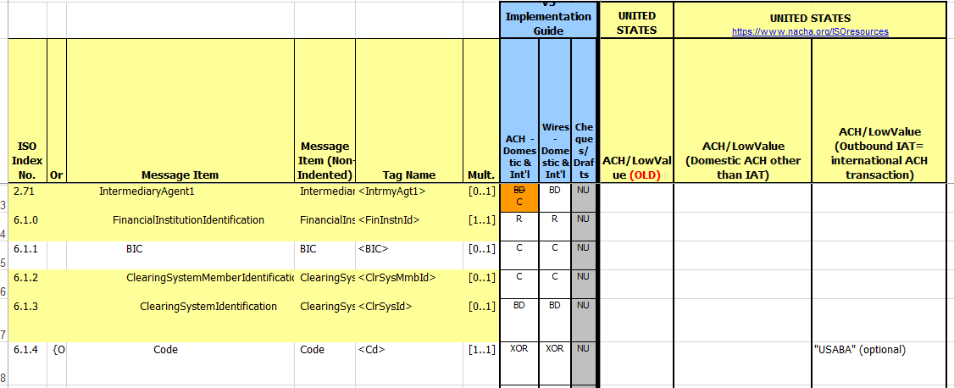

IntermediaryAgent1 Account section / column ACH Domestic & Intl.:
Tag 2.72 IntermediaryAgent1Account – change from NU to BD
Tag 1.1.0 Identification – change from NU to R
Tag 1.1.1. IBAN – change from NU to XOR
Tag 1.1.2. Other – change from NU to XOR
Tag 1.1.3. Identification – change from NU to R
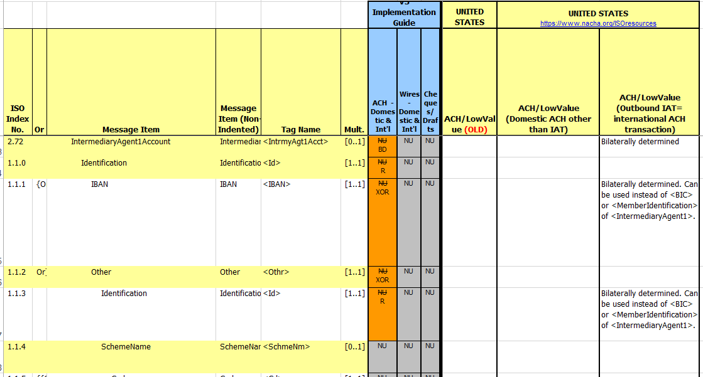

IntermediaryAgent2 section / column ACH Domestic & Intl. :
Tag 2.73 IntermediaryAgent2 – change from NU to C
Tag 6.1.0 FinancialInstitutionIdentification – change from NU to R
Tag 6.1.1 BIC – change from NU to C
Tag 6.1.2 ClearingSystemMemberIdentification – change from NU to C
Tag 6.1.6 MemberIdentification – change from NU to R
Tag 6.1.7 Name – change from NU to C
Tag 6.1.8 PostalAddress – change from NU to C
Tag 6.1.17 Country – change from NU to C
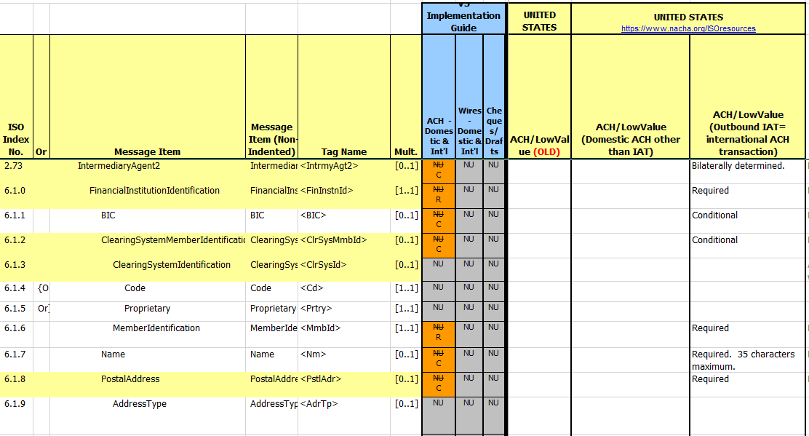

IntermediaryAgent2Account section / column ACH Domestic & Intl. :
Tag 2.74 IntermediaryAgent2Account – change from NU to BD
Tag 1.1.0 Identification – change from NU to R
Tag 1.1.1. IBAN – change from NU to XOR
Tag 1.1.2. Other – change from NU to XOR
Tag 1.1.3. Identification – change from NU to R

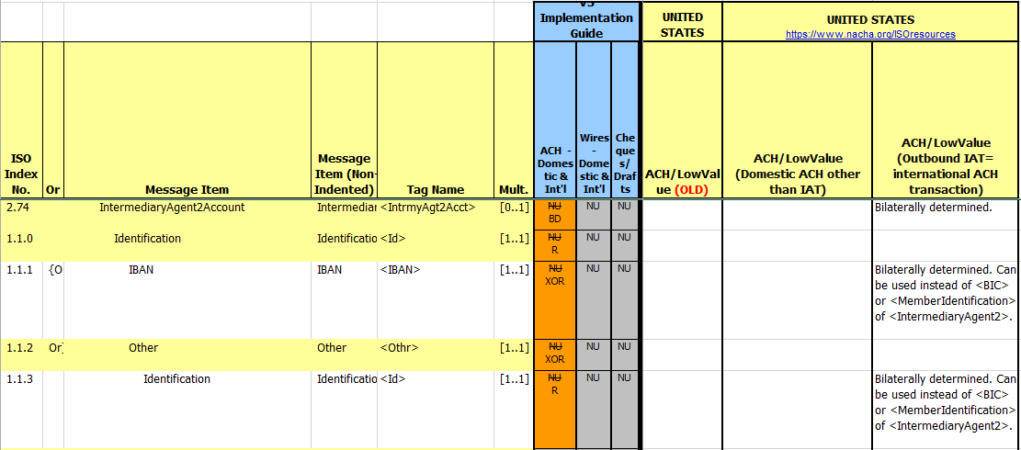

Intermediary Agent3 section / column ACH Domestic & Intl. :
Tag 2.75 IntermediaryAgent3 – change from NU to C
Tag 6.1.0 FinancialInstitutionIdentification – change from NU to R
Tag 6.1.2 ClearingSystemMemberIdentification – change from NU to C
Tag 6.1.6 MemberIdentification – change from NU to R
Tag 6.1.7 Name – change from NU to C
Tag 6.1.8 PostalAddress – change from NU to C
Tag 6.1.17 Country – change from NU to C
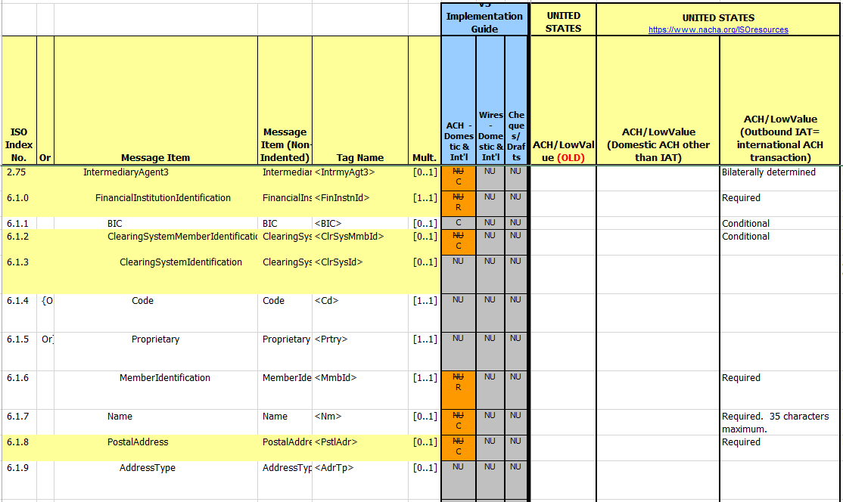

IntermediaryAgent3Account section / column ACH Domestic & Intl. :
Tag 2.76 IntermediaryAgent3Account – change from NU to BD
Tag 1.1.0 Identification – change from NU to R
Tag 1.1.1. IBAN – change from NU to XOR
Tag 1.1.2. Other – change from NU to XOR
Tag 1.1.3. Identification – change from NU to R
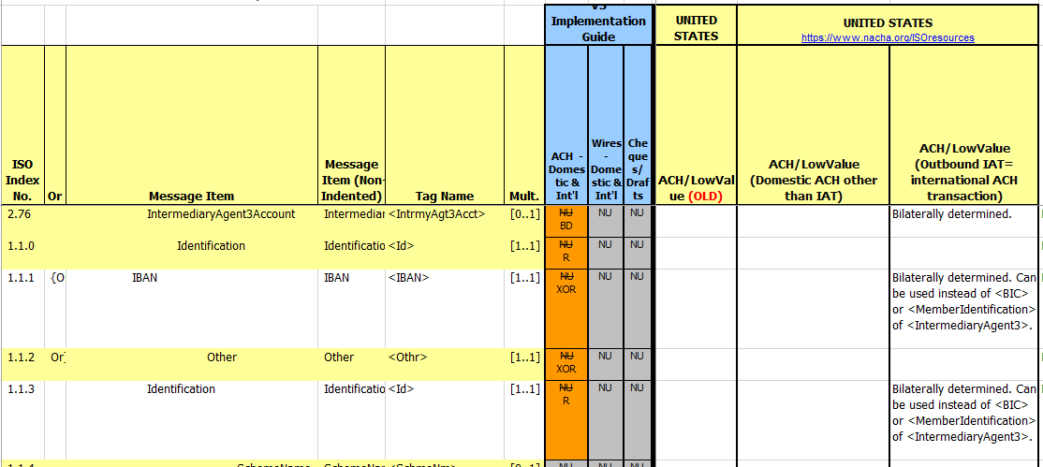

- Purpose of the change:
This section must explain why the CGI-MP normative deliverable needs to be changed. The reason for the update may be a business reason, a technical reason, a regulatory reason or the extension of the user community (newly identified business requirements).
The changes from not used (NU) to used elements are required due to the business review of US NACHA payment types (domestic & international ACH payments). Especially for IAT payments, a lot of intermediary agent and account information may be used.
- Urgency of the request:
If there is a need to have the new version of the related normative CGI-MP deliverables published earlier, the reason for the urgency should be described here. Acceptance of such an unscheduled maintenance is subject to approval of the CGI-MP Plenary.
- Business examples:
If possible examples illustrating the change request.

